Laboratory Activity
Web Systems and Technology
Midterm

Procedure:

Note: Insert/paste all your screenshots/output inside this document. Then upload it to your github. This is a separate filename : Activity 2- 10/28 , and then send to me the link.

- Open your individual unit and check your current PHP version using the command prompt see sample image below : Write the command in the black provided (below)

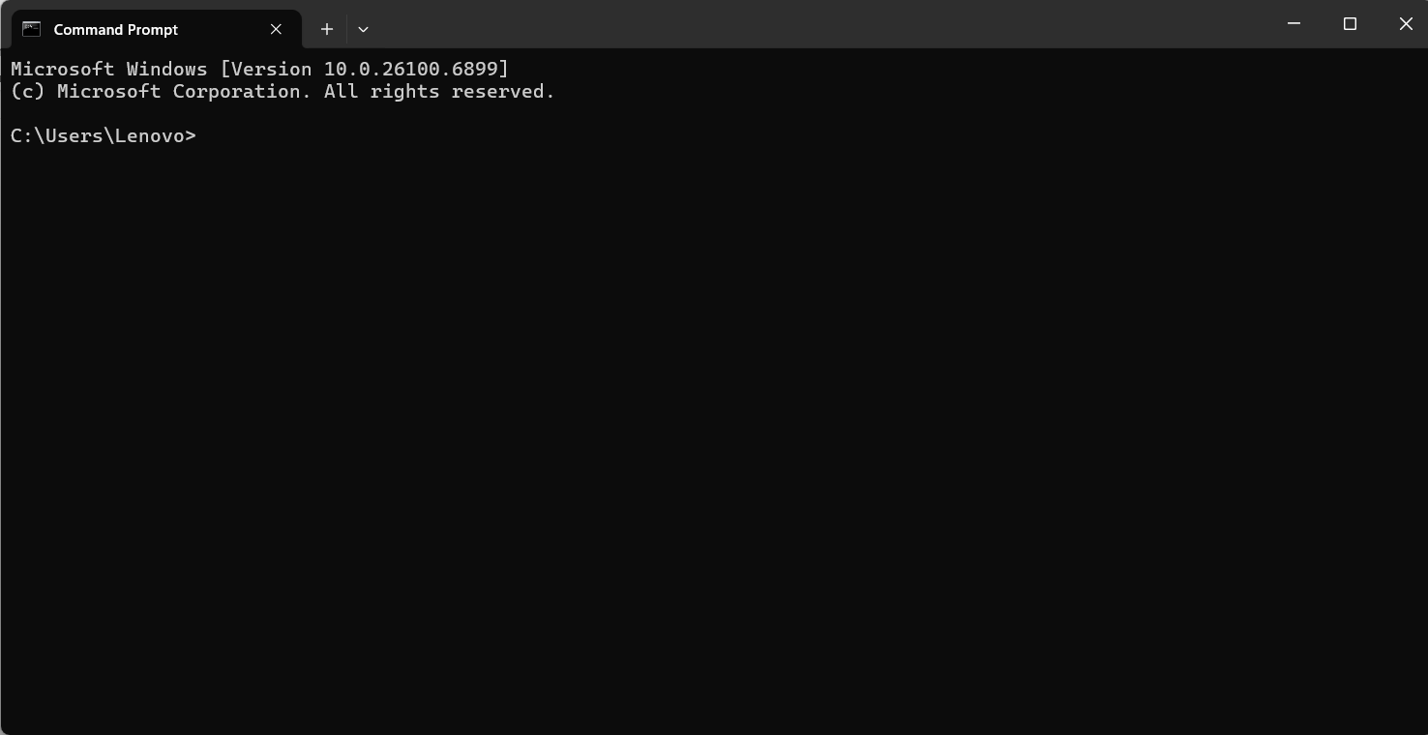

php -v

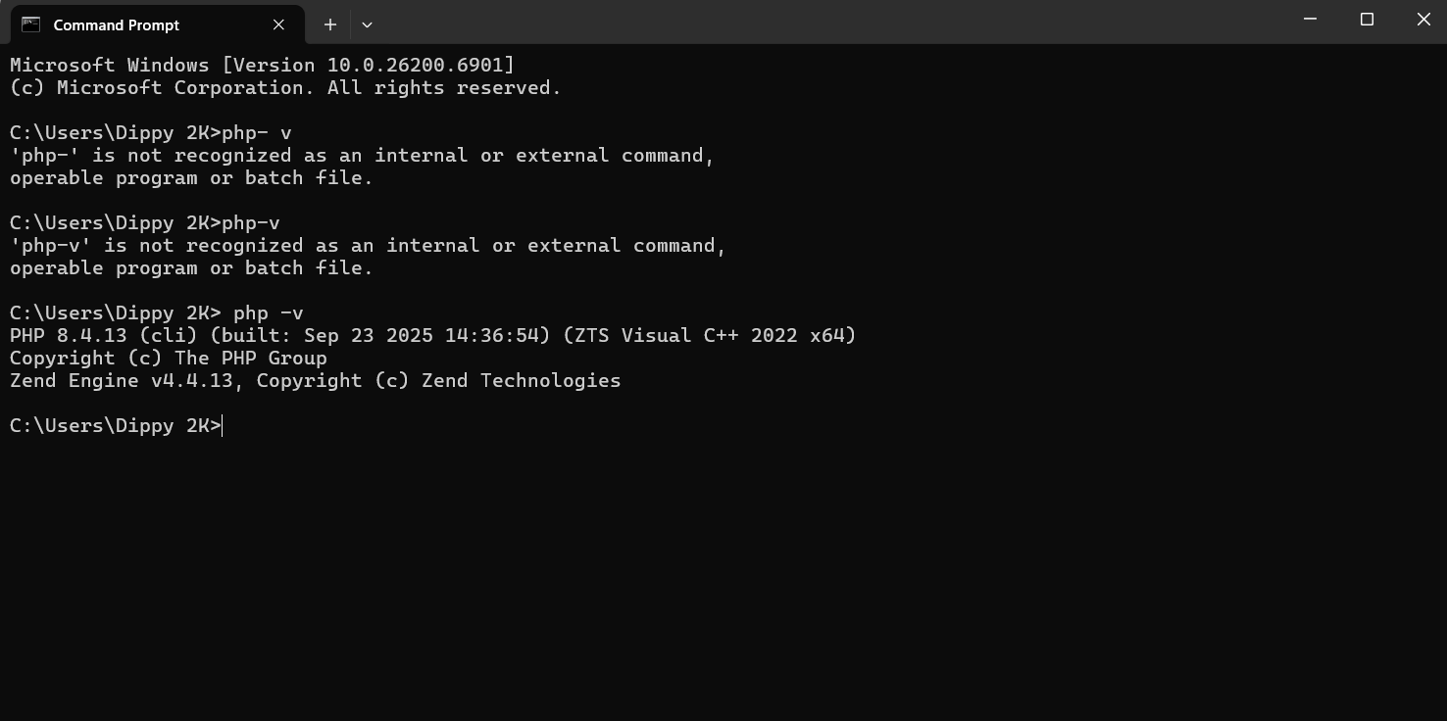
- Then open the XAMPP control panel (see image)
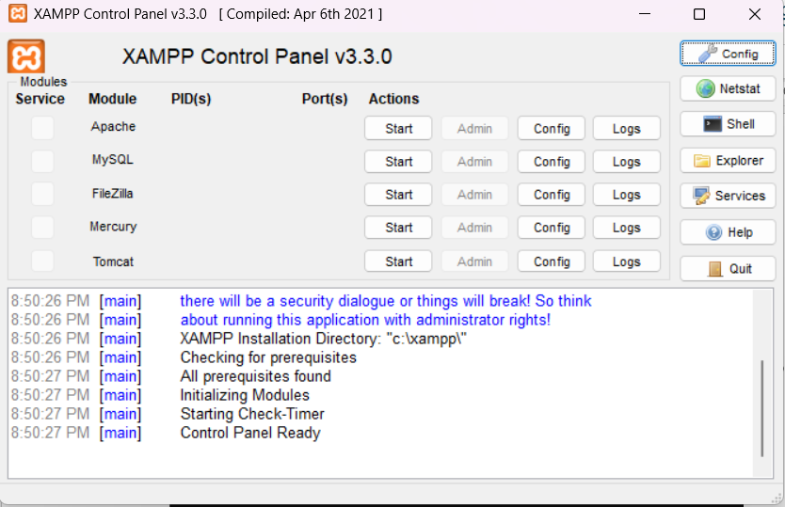
Make sure to click the Start button to open the Apache and MySQL

- Once it green your server is now running

- Make sure to check the ports of Apache and MySQL as follows
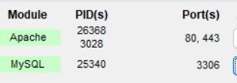
- Your now ready to test your server
- Access the XAMPP dashboard in a browser
  - Open your preferred web browser and type http://localhost into the address bar and press Enter.

  - If XAMPP is working correctly, you will see the XAMPP welcome page, which confirms the Apache web server is running.
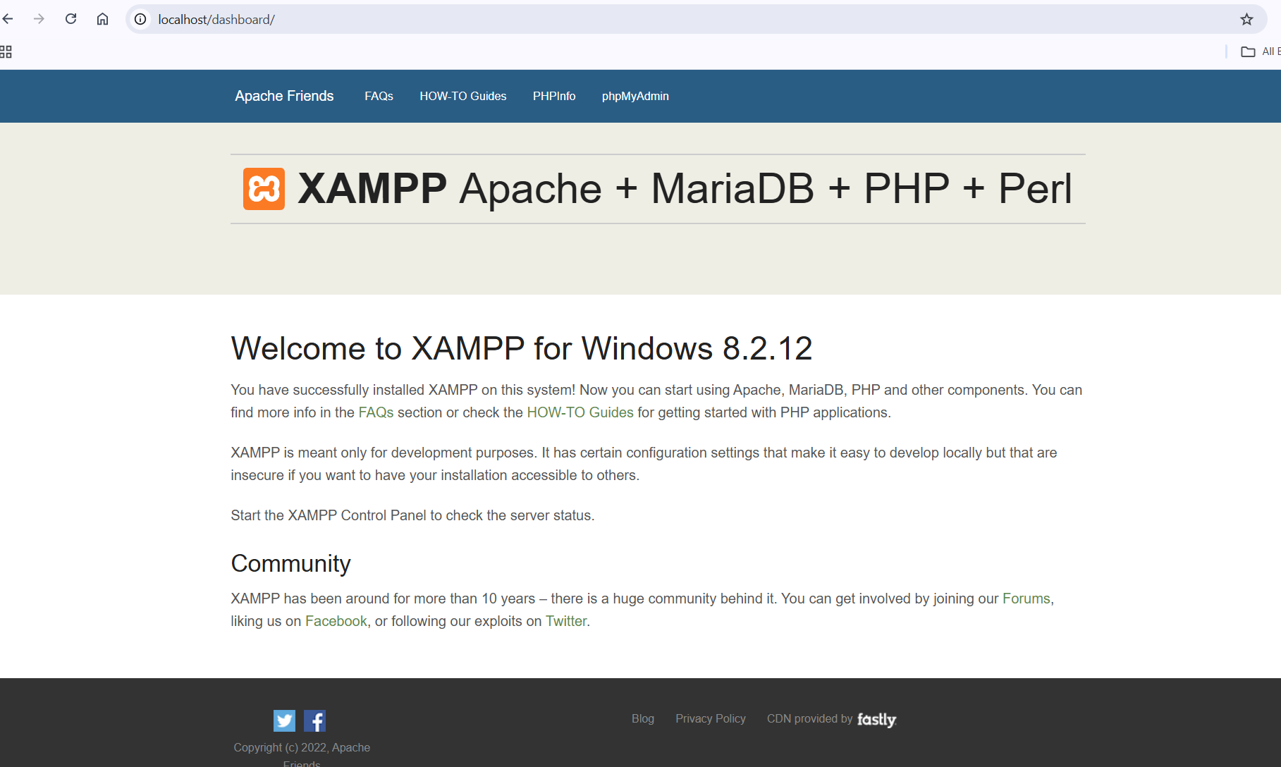
  - Alternatively, you can type http://127.0.0.1 to get the same result.
- Next, open your VS code app if the following Extension are available and properly installed
  - PHP server
  - Live server
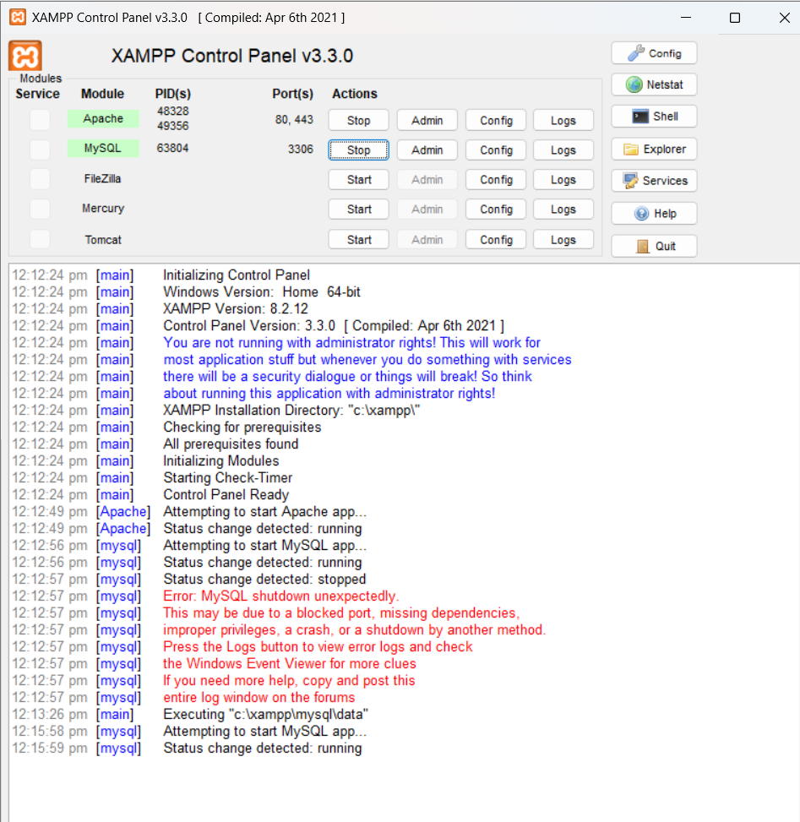
  - PHP intelephense
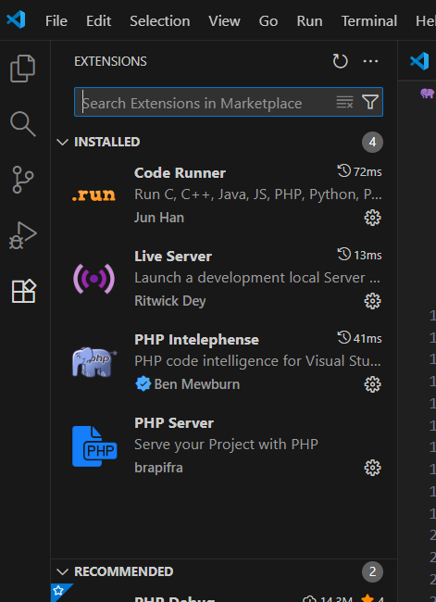

- Once installed start your first PHP code

First thing first create a folder inside your XAMPP
- Locate your root folder. Open the XAMPP Control Panel and click the Explorer button to navigate to your installation directory, typically C:\xampp\ on Windows.
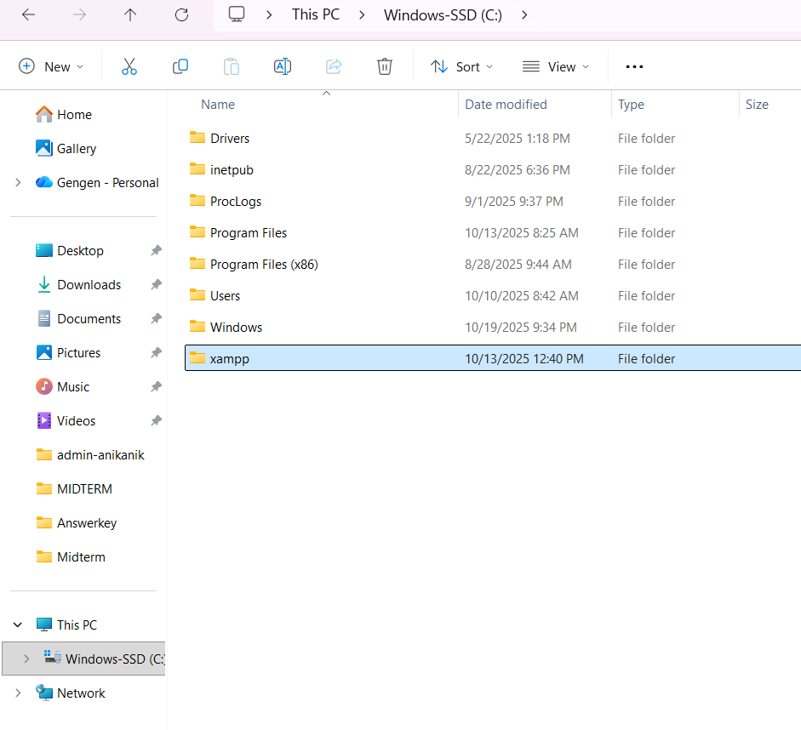
- Find htdocs. Open the htdocs folder. This is the root directory for all your web projects.
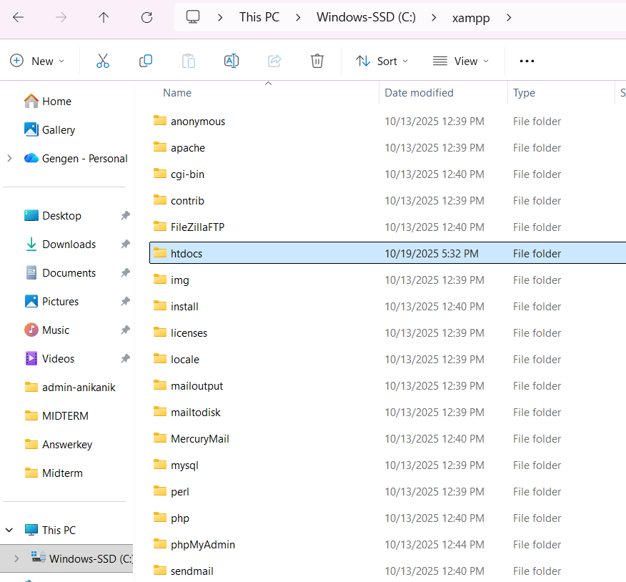
- Create a project folder. Create a new folder inside htdocs for your project (e.g., C:\xampp\htdocs\MyWebsite(any name you set)).
- After creating the Filename inside htdocs, open your VS CODE app then
- Then locate this folder as show in the image below
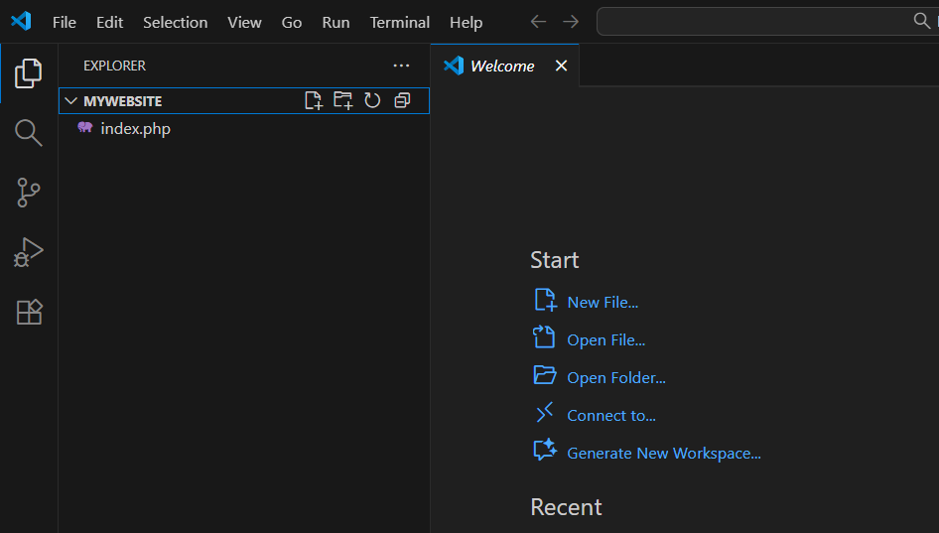

- Save your projects
  - you need to save your files in the correct directory.
- Create at least one sample code using the following.
  - Concatenate String
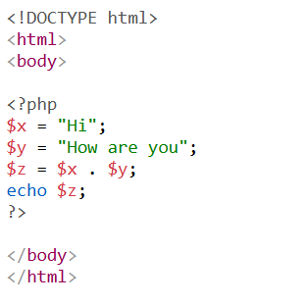

  - Math Functions
  - Loops
  - Constants
  - PHP Superglobals
  - Sample Form Handling
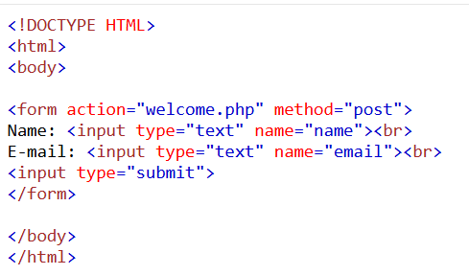
Note: Don’t forget to save your sample with PHP extension (e.g index.php)
- Display an output for each sample
  - Access your project. To view your website, go to your browser then type http://localhost/MyWebsite (or the name you set) . If you created a specific file, such as index.php, you would visit http://localhost/MyWebsite/index.php (or the filename you saved)

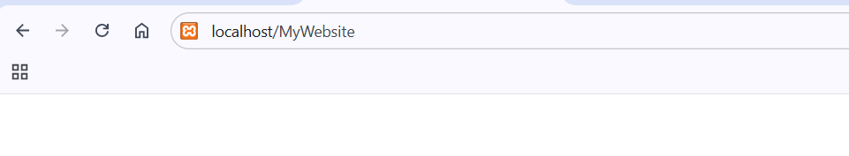

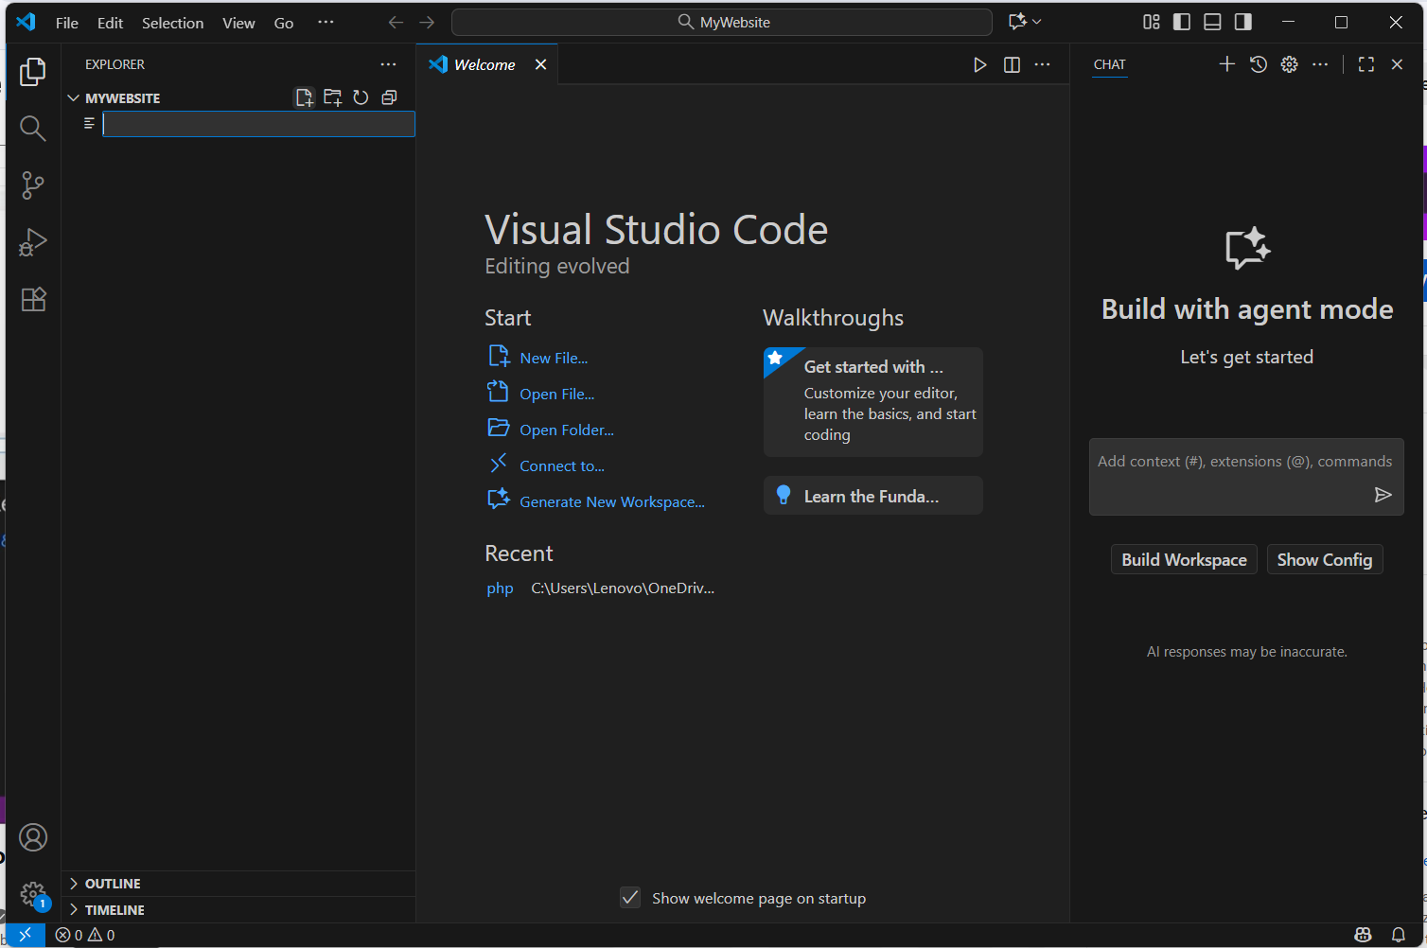

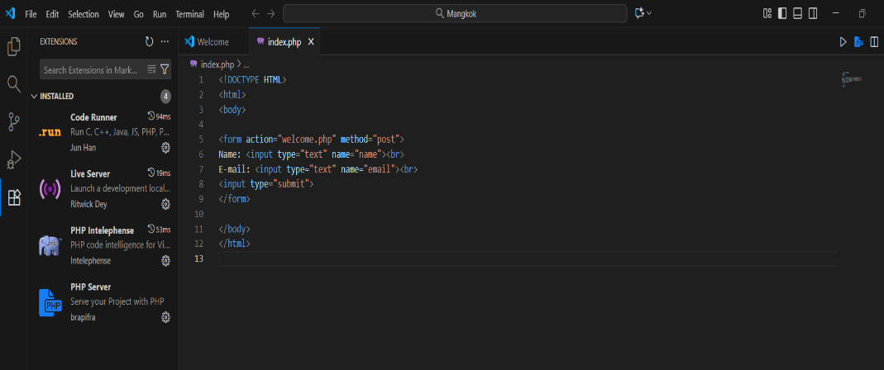
Screenshots:

